QIGONG HALF-DAY RETREAT
Qigong and Dharma
Embodying Hope and Balance
With Don Coleman, Steven Spiro, and Suzanne Kilkus
Saturday, November 7th, from 10:30—1:30
Madison Tai Chi Center, 1304 S. Midvale
Please join us in person for this intensive, relaxing experience.
This event is appropriate for all ages and skill levels.
It will be available live and on zoom.
RSVP to: steven@stevenspiro.com

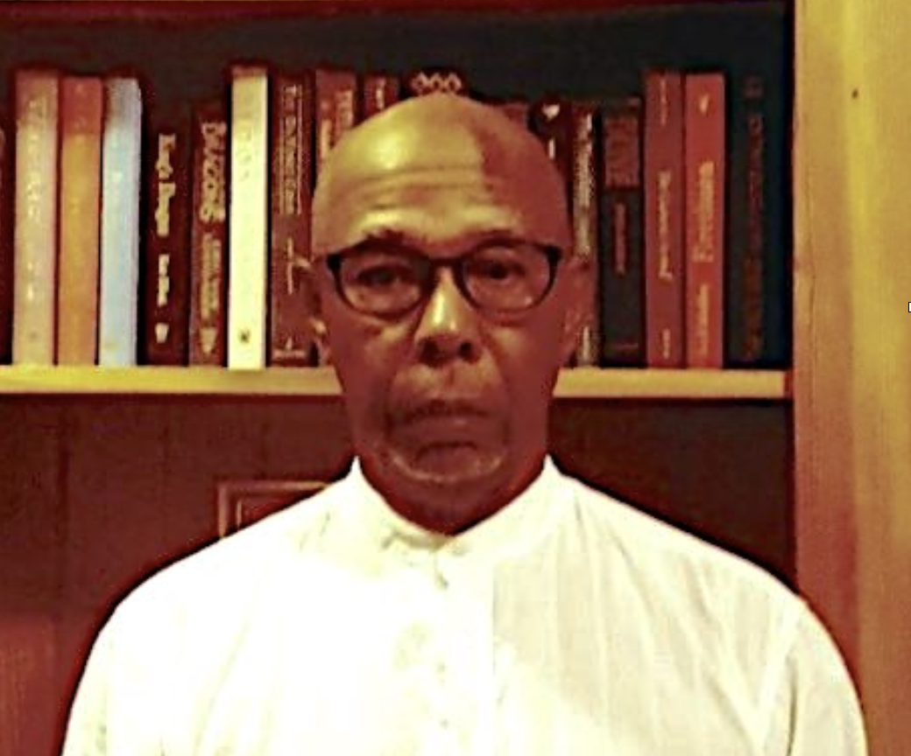
Teachers
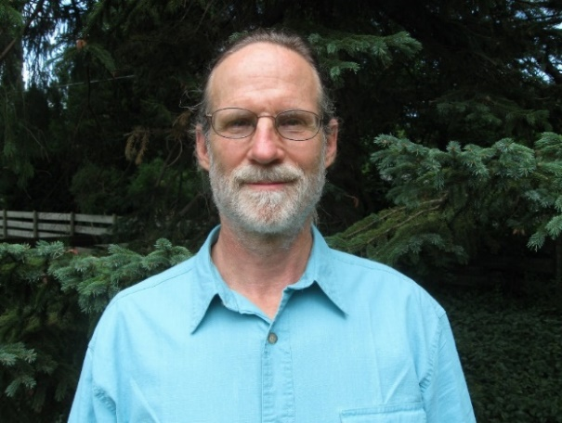
Don Coleman has studied and practiced internal boxing art (Taiji, Hsing Yi, & Bagua), for 50 years. Included in these systems are various Qi Gong and Neigong methods. He is an initiated Daoist in The Immortal Ancestor Gold Mountain Daoist School of Internal Alchemy and a Boddhisattva in the Appamada Zen Community - Open Door Zen Community. From 1989 until 2015 Don and his life Partner Kathryn’s Empty Mind Full Belly School of Internal Art (later renamed Madison Daoguan) offered Yang Family Taiji Quan, Yang Family Hidden Tradition of Taiji Quan, Bagua Zhang, Buddha Hand Qi Gong, Taiji Qi Gong, Neigong, Daoist Tranquil Sitting, and Mindfulness Awareness Practice. Don's primary teachers are Tsuei Wei (Taiji) Wang Yen-nien (Abbot of Gold Mountain School, Taiji), Grady Elliott (Bagua, Hsing Yi), James Sauer (Bagua), and Koshin Flint Sparks (Zen Buddhism).
Steven Spiro has been studying, practicing, and teaching Qigong for over 30 years. His primary focus is Breathing Earth Qigong, which he developed especially to enhance Buddhist meditation techniques. He has taught at numerous retreats, to students and teachers in schools, in prisons, corporations, in end-of-life contexts, and at Upaya Zen Center in Santa Fe. Presently he teaches with the Madison Tai Chi Center. His primary teachers have been Tricia Yu, Ken Cohen, Chunyi Lin, Lee Jun Feng, Thich Nhat Hanh, Bernie Glassman, and Roshi Joan Halifax. He is a Zen Buddhist chaplain, a core member of SnowFlower Sangha in Madison, and a Prison Dharma Teacher.
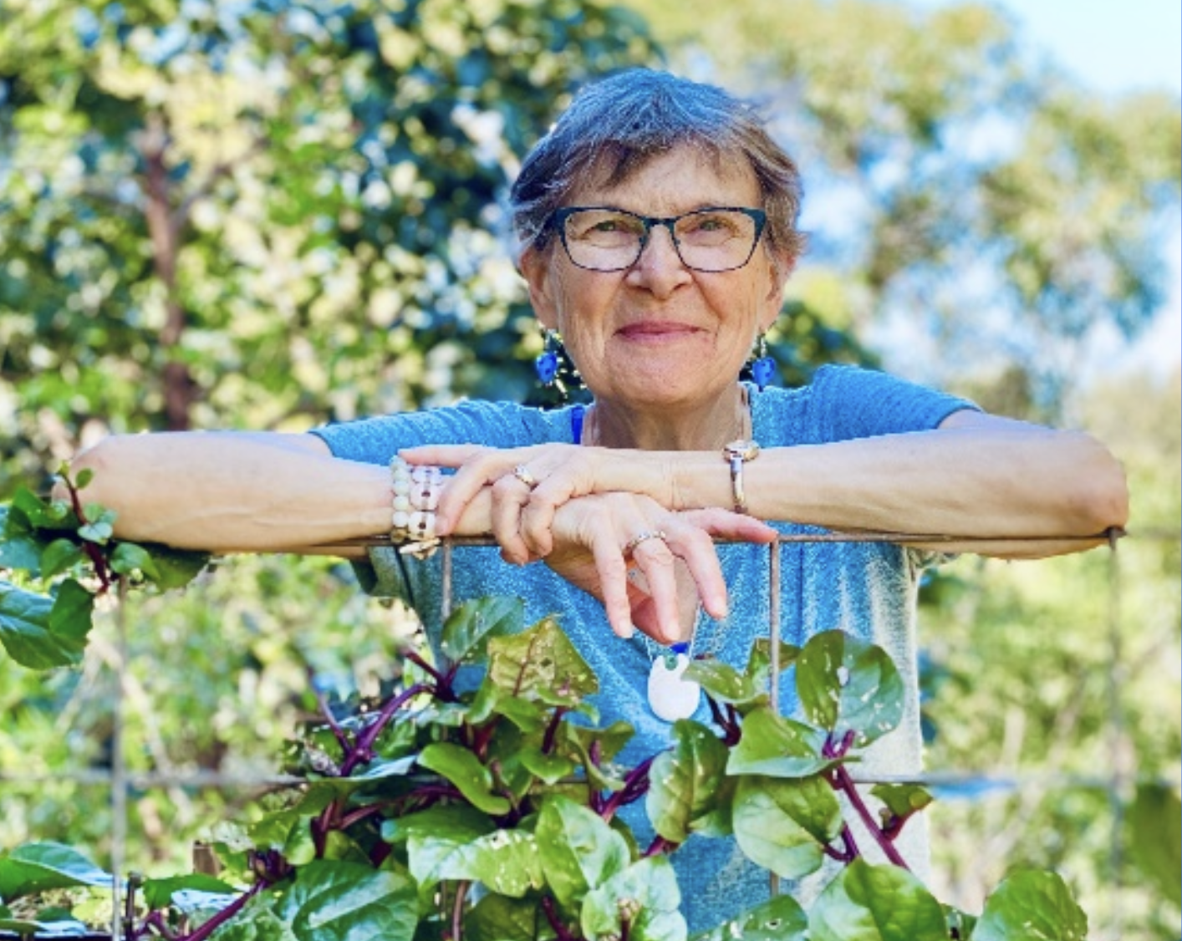
Suzanne Kilkus is the entrusted resident teacher with Open Door Zen Community, Madison, Wi since Oct 2020. Her primary teacher is Flint Sparks of the Appamada Community in Austin TX. She has a 40-year meditation practice and has been a Zen student since 2002. She began studying qigong in 2016 with Master Chunyi Linn of Spring Forest Qigong and has also studied with Master Daisy Lee of Radiant Lotus Qigong. As a teacher and spiritual guide, she is committed to encouraging the expression of Basic Goodness in each person and for the community. She invites each person’s unique offerings of compassion, love, and wisdom.
Please join us in creating and discovering ancient pathways into wellness and buoyancy in the midst of trying times.

When RSVP-ing to steven@stevenspiro.com please indicate if you will be joining in-person or via zoom. Payment is by donation. Participants practice dana (“giving”) according to each person’s ability, based on the value of the experience. More info will follow.

